Comorbidities Project Documentation (JavaScript)

**Project Code Access Instructions:**

1. Connect to ipsecvpn.uhmc.sunysb.edu using Cisco Anyconnect Security Mobility Client. Enter “iramakris” and “Dcba@@52” for the username and password fields respectively.

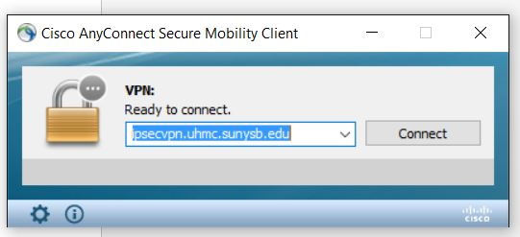

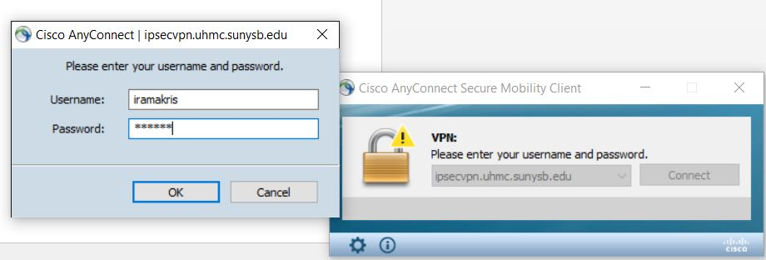

1. A Cisco AnyConnect dialog box appears that asks us to connect to Stony Brook Medicine VPN Connection. Click “Accept”.

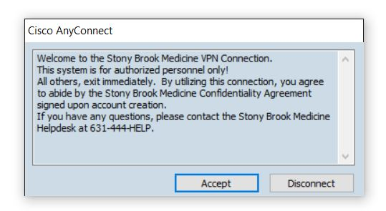

1. Enter <https://uhmc-ctx-web.uhmc.sunysb.edu/Citrix/XenApp/auth/silentDetection.aspx> on the browser. A login prompt appears. Enter “iramakris” and “Dcba@@52” in the username and password fields respectively again to log in into the application.

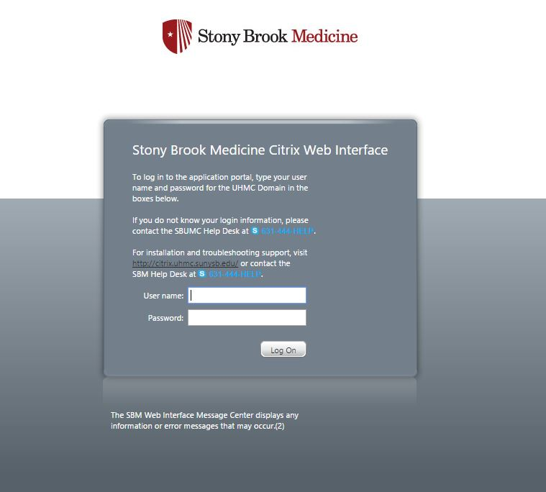

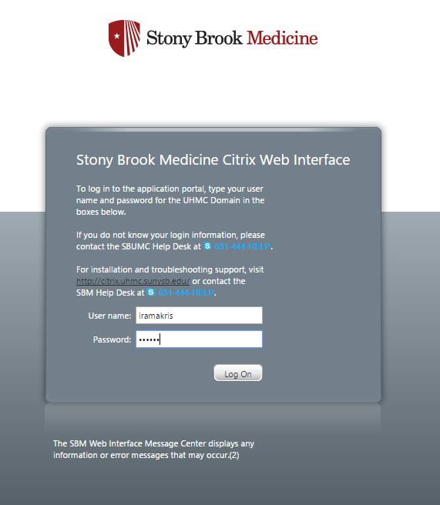

1. Click on the CernerC159 folder.

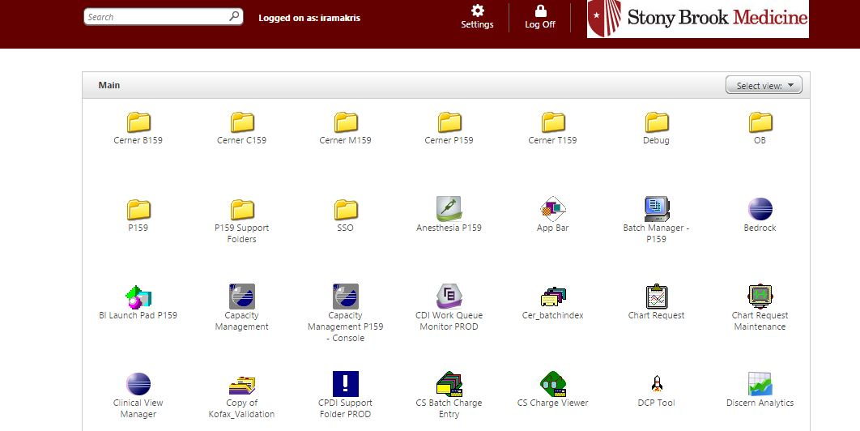

1. Click on the FirstNetC159 folder to gain access to the patient list.

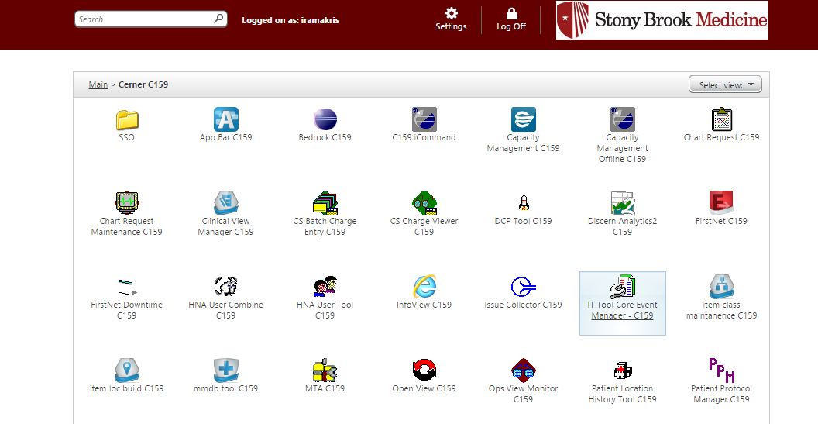

1. A launch.ica citrix receiver application gets downloaded. Install the citrix receiver if not already installed. Make sure that the citrix receiver is running in the background. Click on the downloaded launch.ica application to run it.

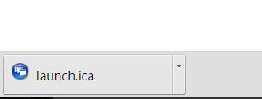

1. When prompted for username and password again on the C159 domain, enter “iramakris” and “ivfirstnet18” respectively to login (If you can’t login using the username and password, please don’t try more than 2 times, and contact professor for help).

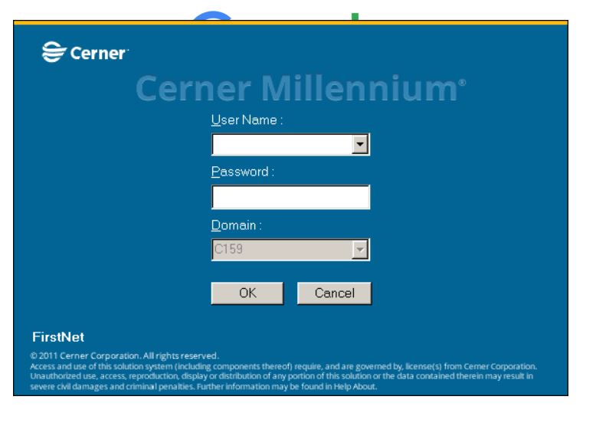

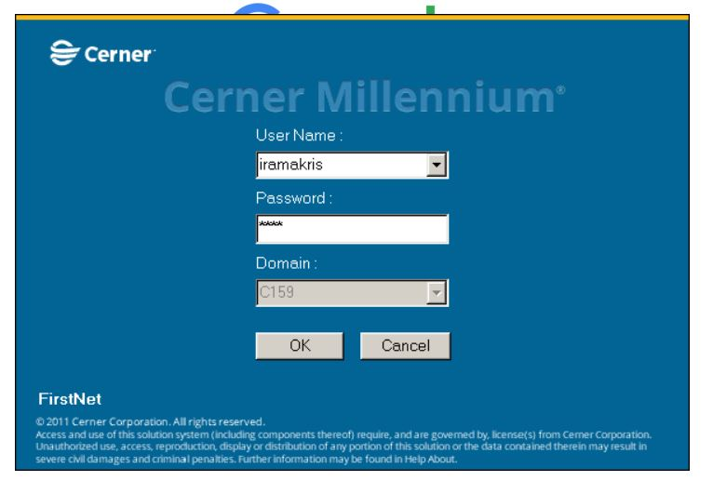

1. Enter “no” if asked to be checked in as an available provider.

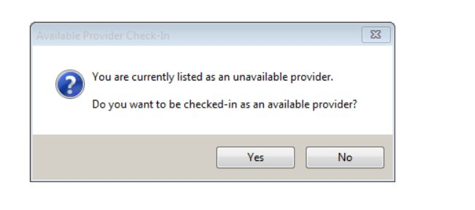

1. Click on the “patient list” column in the task bar to gain the list of patients.

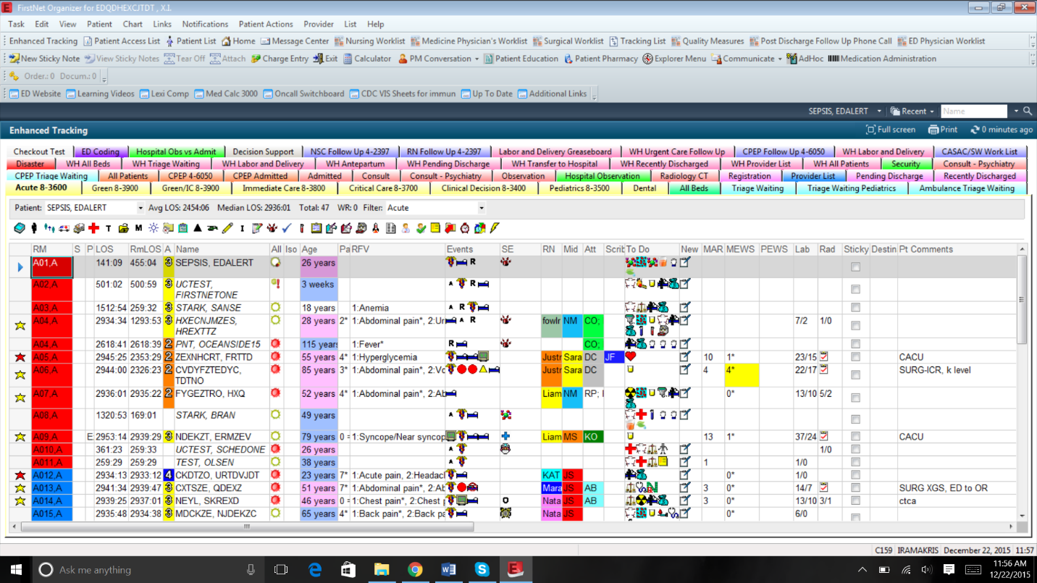

1. Once the patients list appears, click on 04L8-ED Acute Care.
2. A list of patients shows up. Click on any patient whose details are to be accessed.

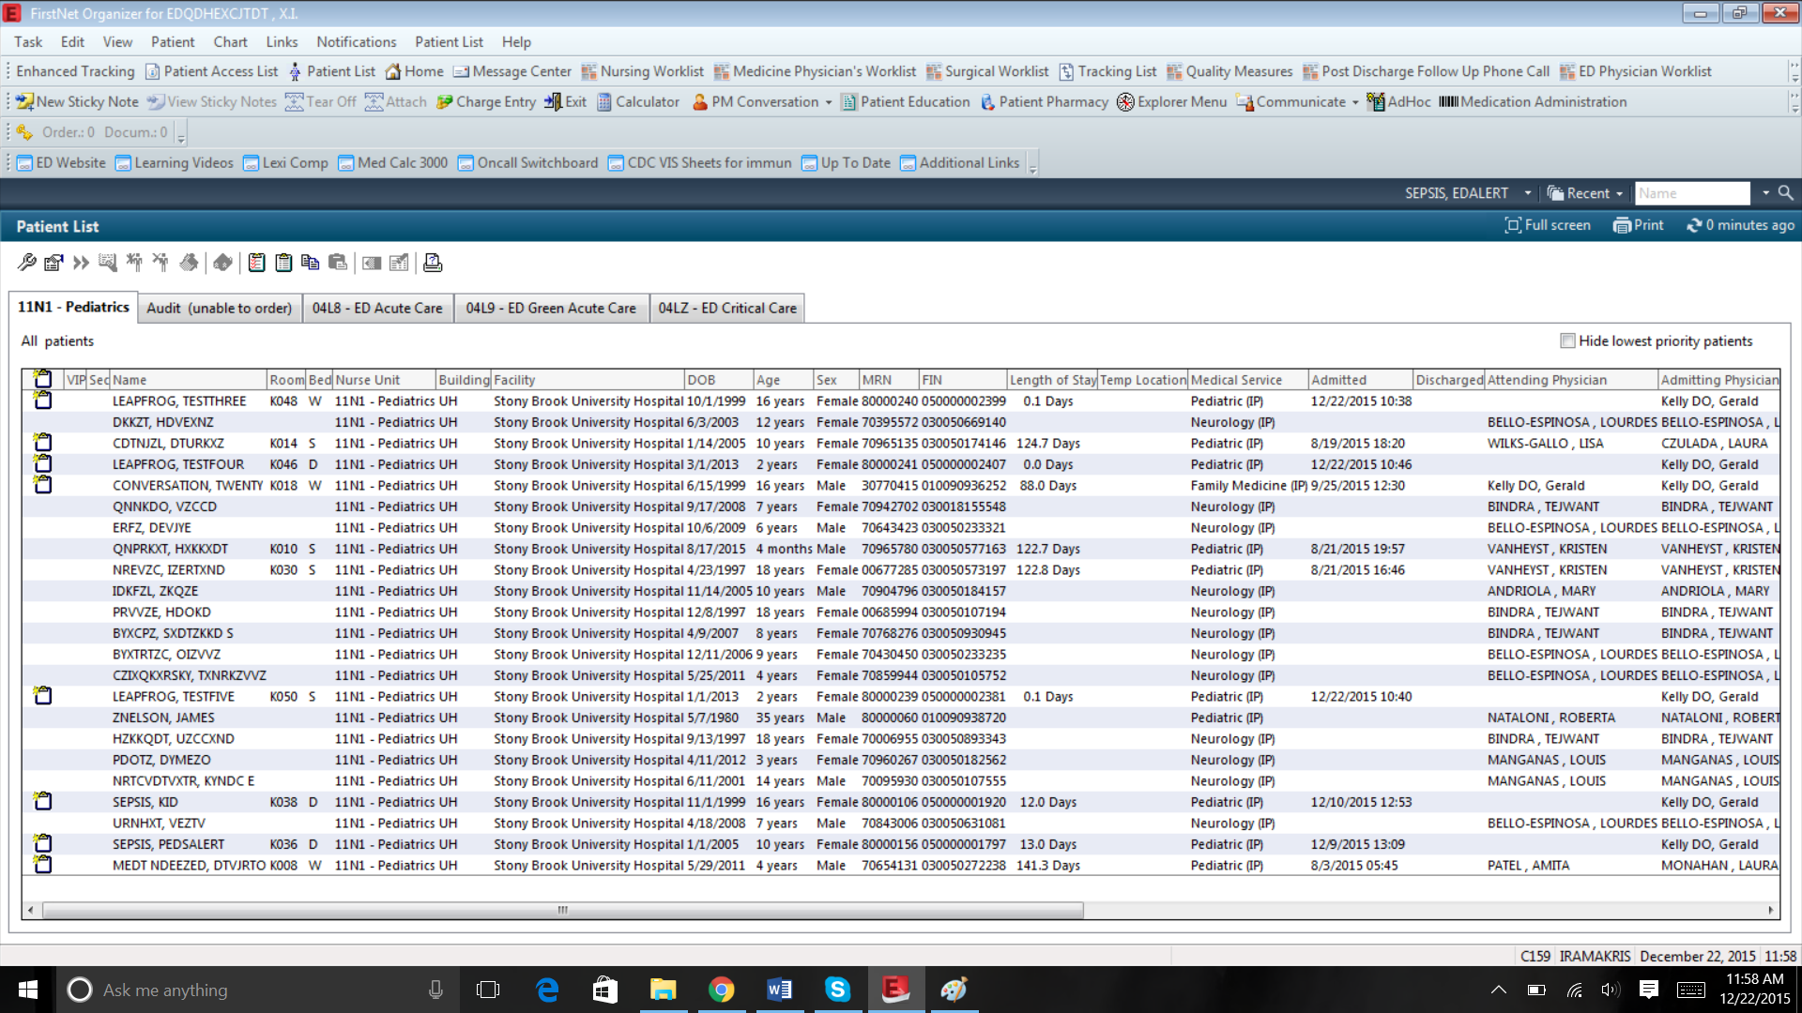

1. All the details associated to the patient is available. Go to the Co-Morbidity (Testing) folder, which is the last folder on the left hand side list of all available folders. The column “CoMorbidities from Radiology Report” displays all the radiology related comorbidities extracted from the radiology reports of the corresponding patient.

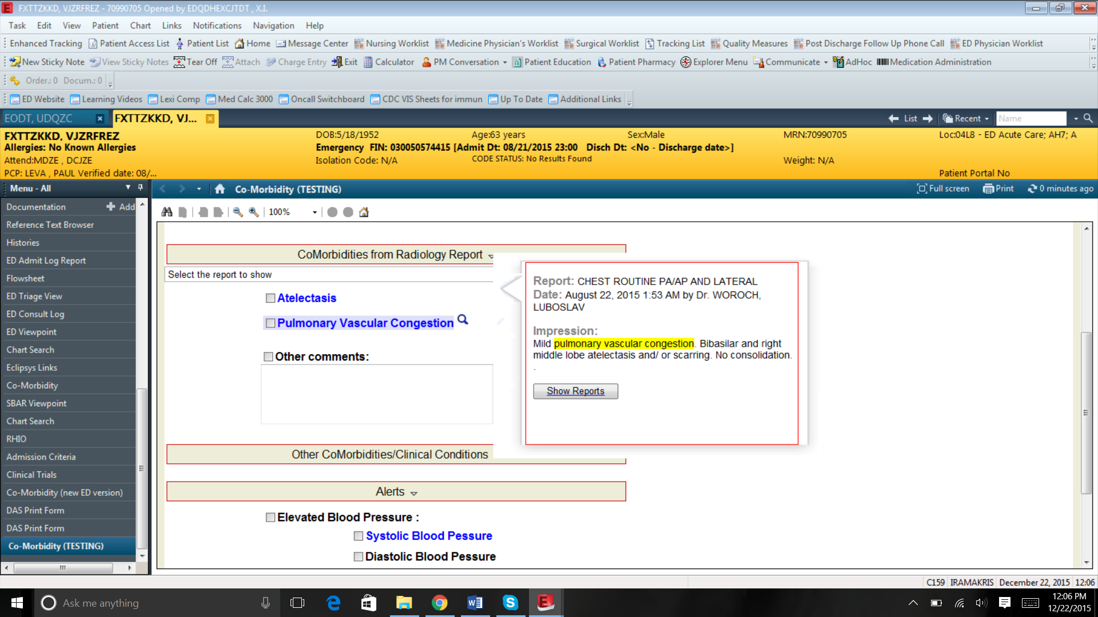

**Accessing the source code for the Comorbidities (JavaScript):**

1. Connect to ipsecvpn.uhmc.sunysb.edu using Cisco Anyconnect Security Mobility Client. Enter “iramakris” and “Dcba@@52” for the username and password fields respectively.
2. Enter <https://uhmc-ctx-web.uhmc.sunysb.edu/Citrix/XenApp/auth/silentDetection.aspx> on the browser. A login prompt appears. Enter “iramakris” and “Dcba@@52” in the username and password fields respectively again to log in into the application.
3. Click on the CernerC159 folder.

These 3 steps are the same as above.

1. Click on the UNVRNYCTX148 C159 Support Folder.

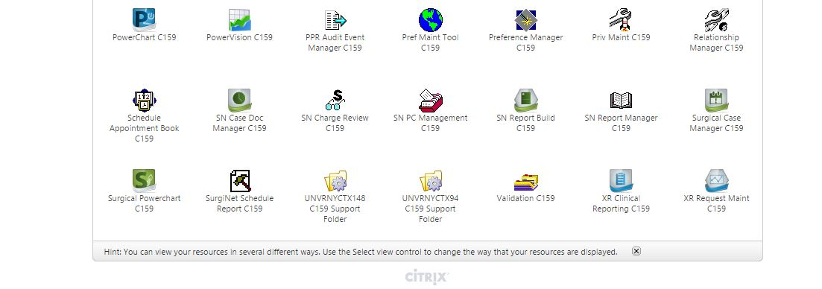

1. A launch.ica application gets automatically downloaded into the computer. Click on it to run the same.

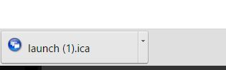

1. Click ok for the accessibility dialog box that appears.
2. A window named “Support Folder” opens up. Click on “Code Warehouse”.

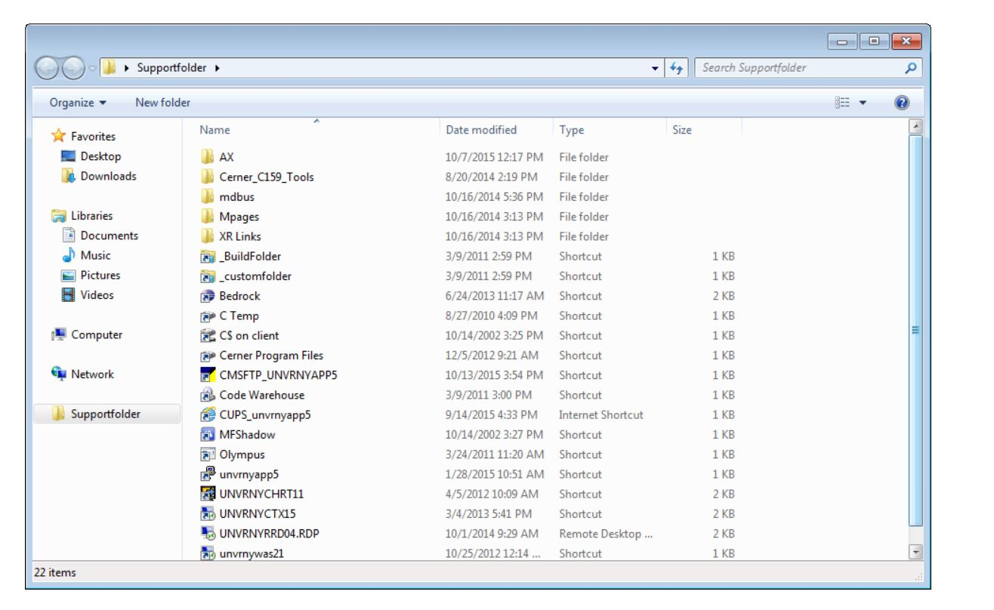

1. A window titled “C159(\\unvrnynas\unvrny)(I:)(I:))” appears which contain a set of folders. Choose “WININTEL” folder and double click on it. Click on folder titled “static content”.
2. Further, click on folder “uhmc_mp_comorbidity3” and go inside that folder. This contains the folders related to Radiology reports. There is a “js” folder here which houses all the java script files related to radiology.

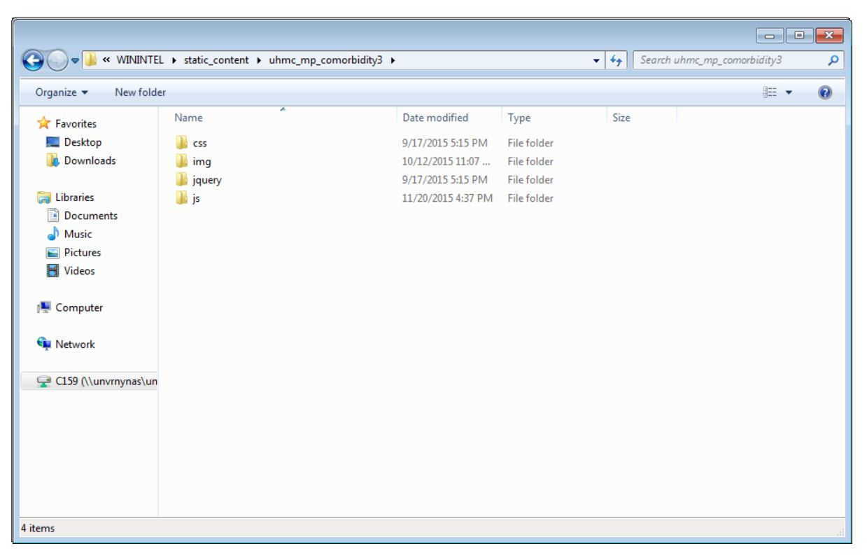

**Accessing html code:**

1. Click on Cerner_C159_Tools in UNVRNYCTX148 C159 Support Folder.

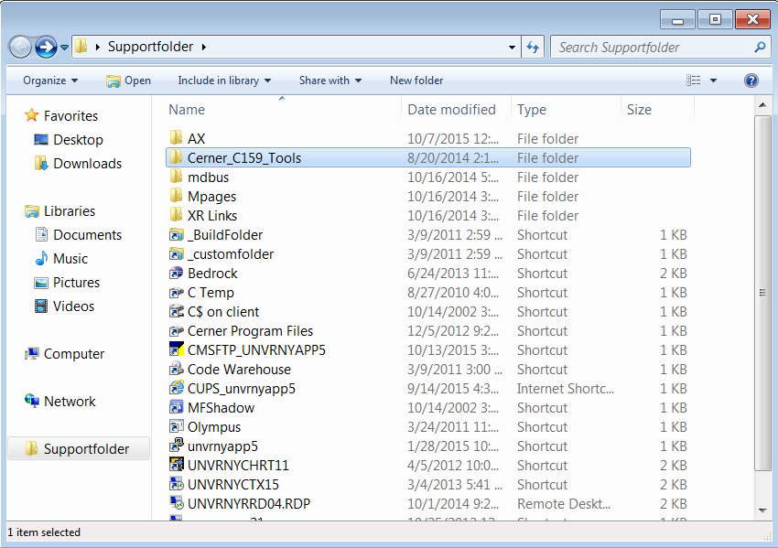

1. Click on Discern.

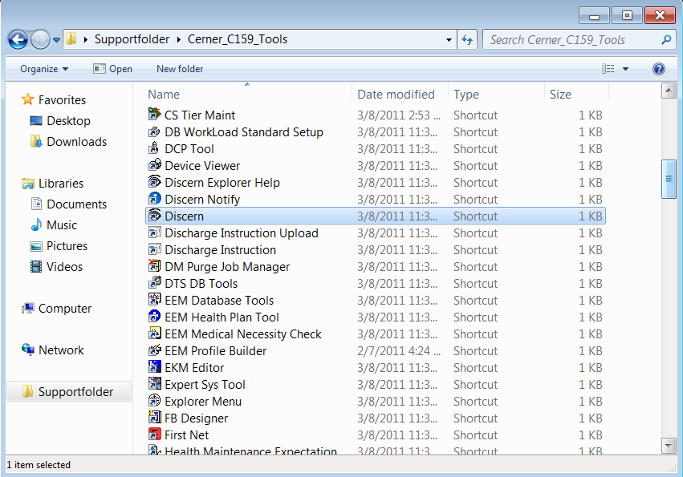

1. Login using “iramakris” as user name and “ivfirstnet18” as password. (If you can’t login using the username and password, please don’t try more than 2 times, and contact professor for help).

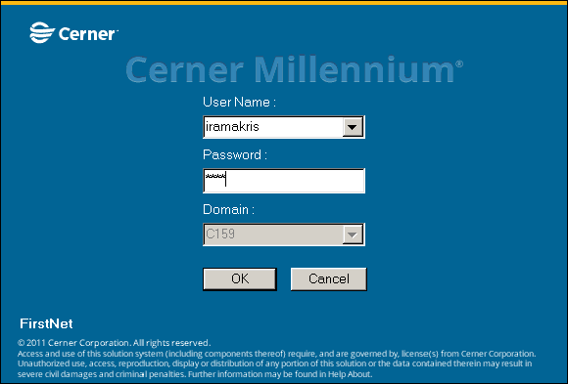

1. Click on Discern Visual Developer.

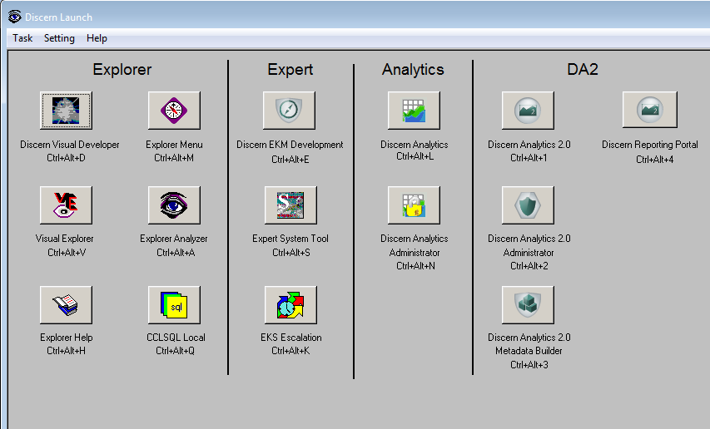

1. You will see a page like below, the html file is called uhmc_mp_comorbidity3.html.

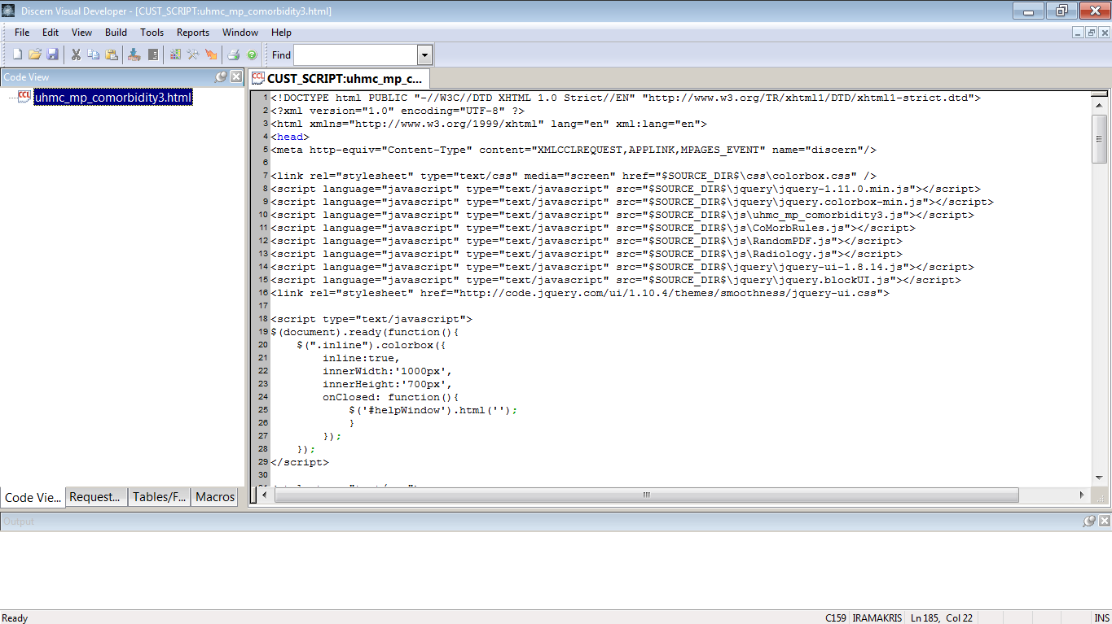

1. If it’s not opened, open source like below.

